**P5 – set up a standalone computer system**

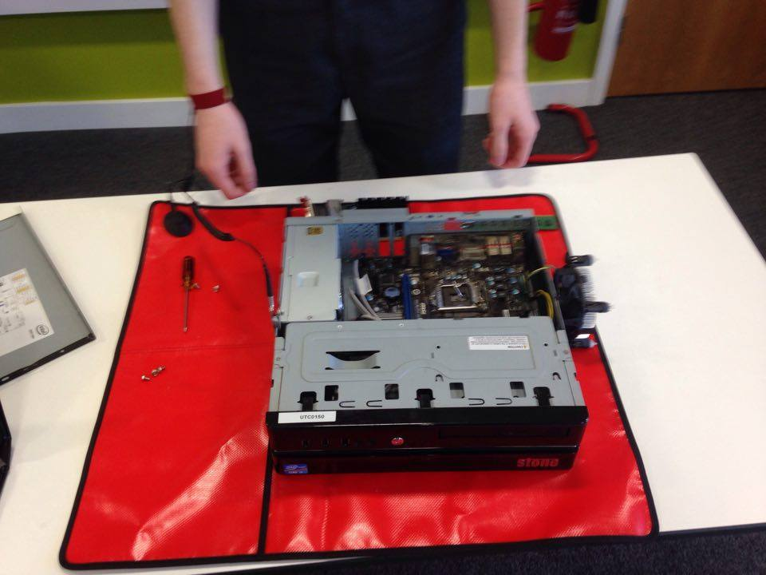

This is the PC with just the motherboard, power supply and hard drive installed – no RAM, no CPU, and no video card. It is on an anti-static mat, to avoid ESD.

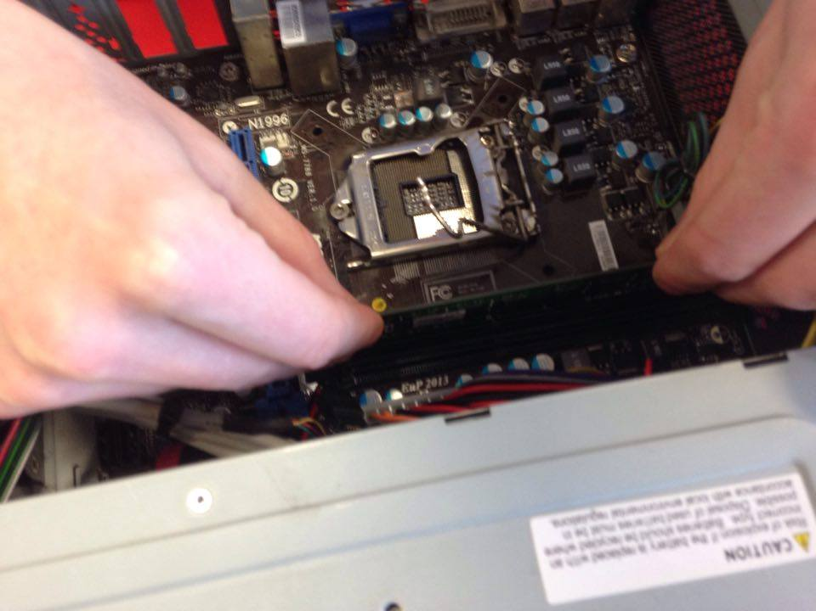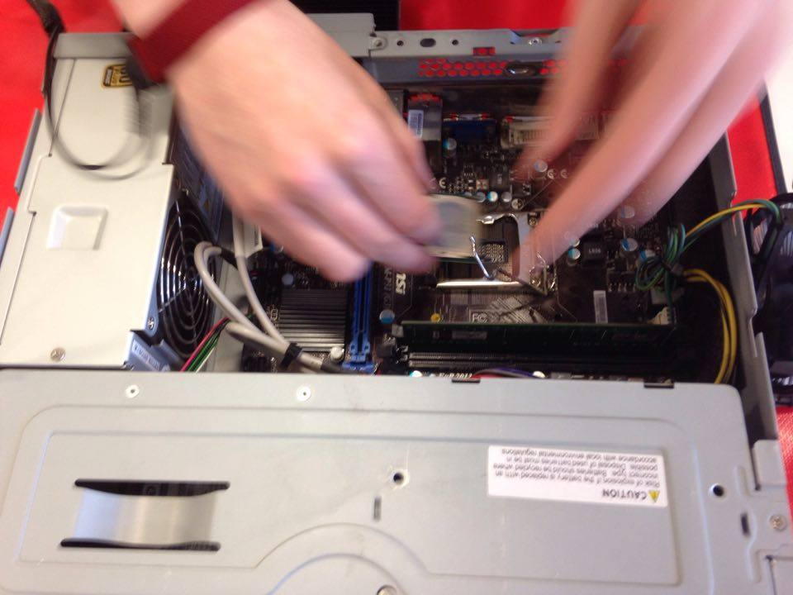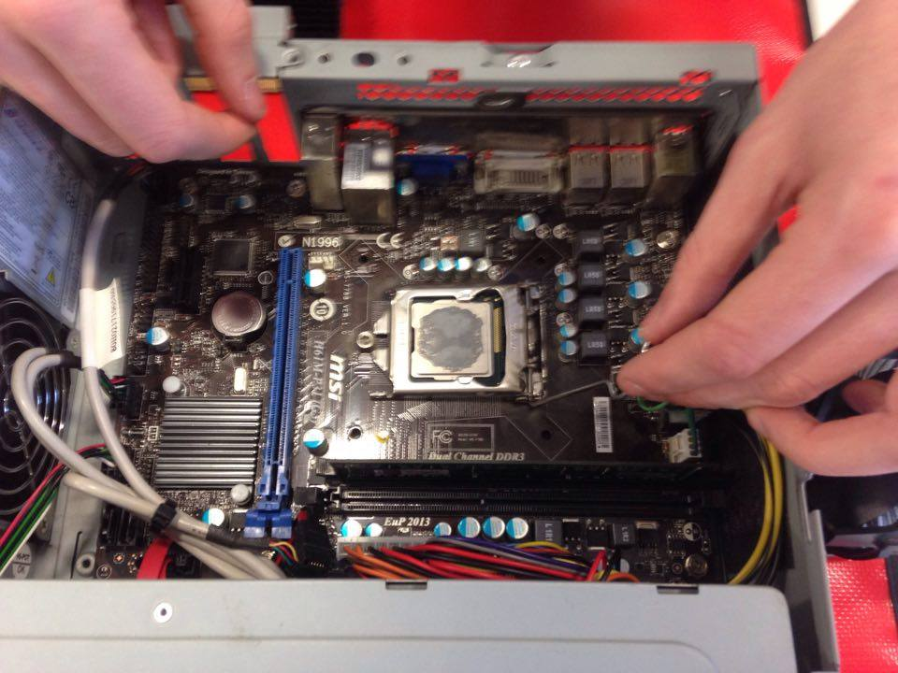

This is the RAM being inserted. There is only one 2GB stick of RAM

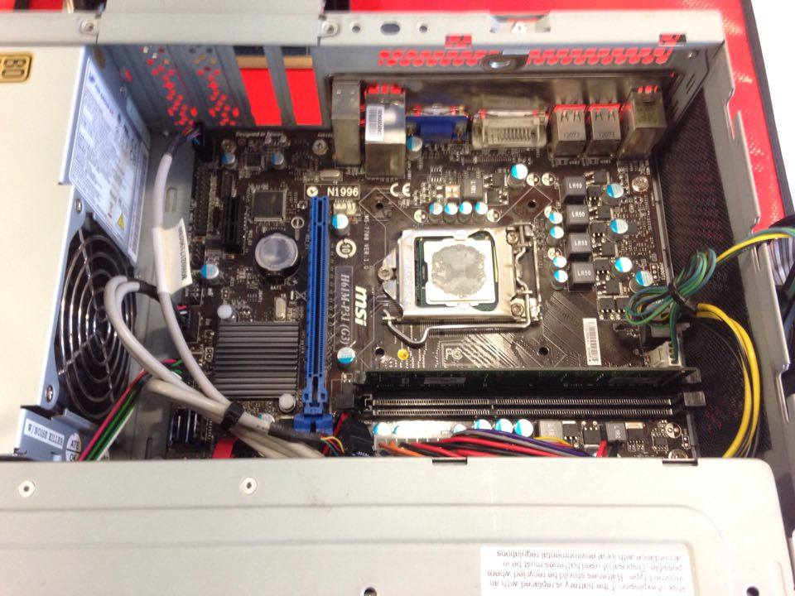

These three images show the CPU being inserted and secured in place. The grey blob on the CPU is thermal paste, which helps transfer heat to the fan and heat sink.

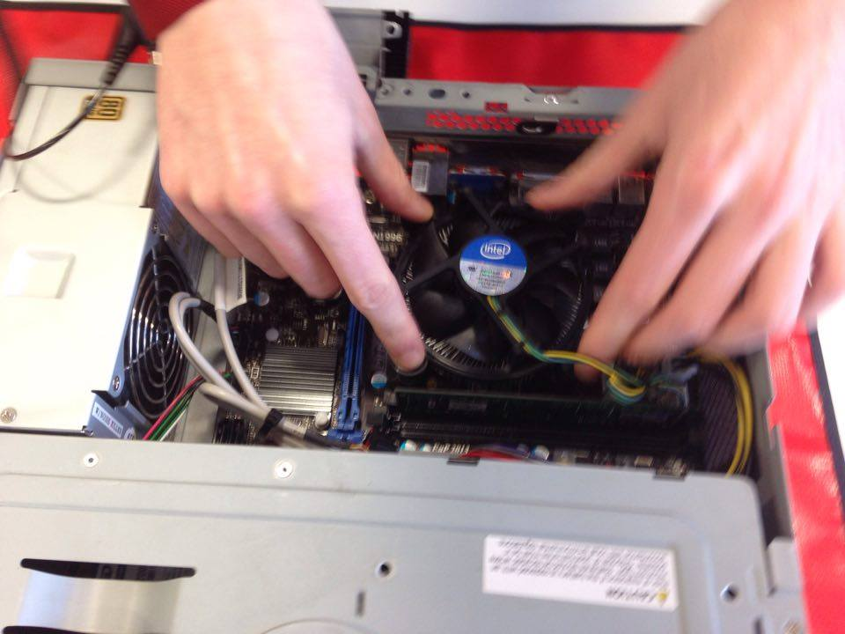

This is the fan being inserted. It keeps the CPU and other components cool. It has four clips, one in each corner, to hold it against the CPU.

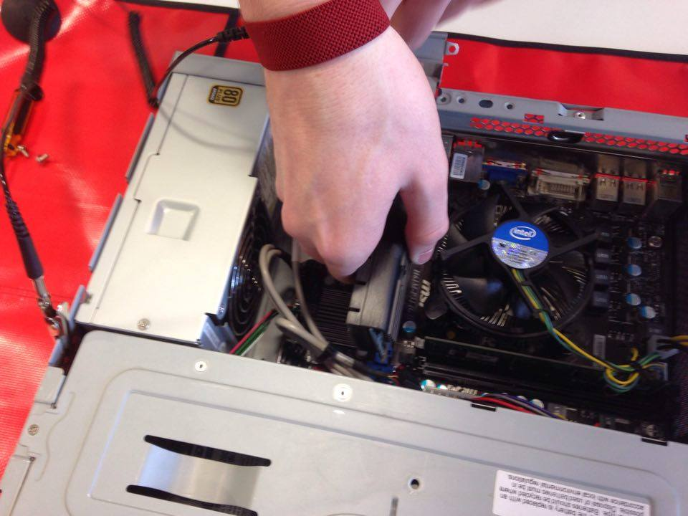

This is the GPU being inserted into the PCI slot. The GPU handles video rendering to reduce the load on the CPU. This card had one VGA and one DVI output.

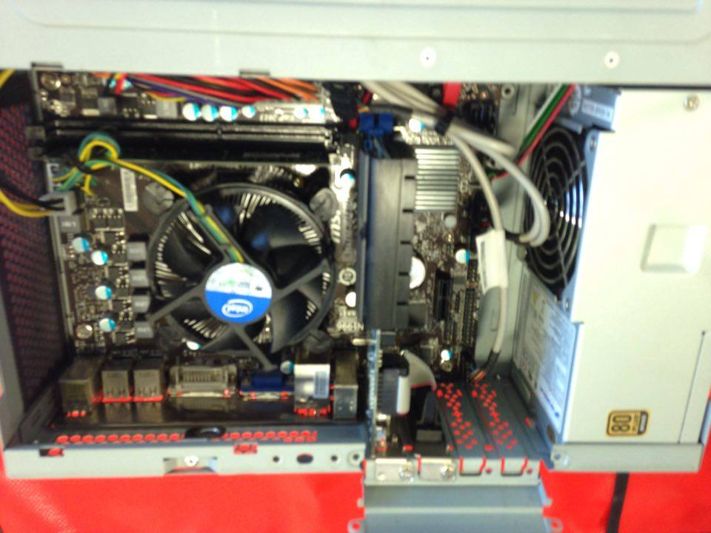

This is the completed motherboard, with  
RAM  
CPU & fan  
GPU  
PSU

The video card outputs are secured in place

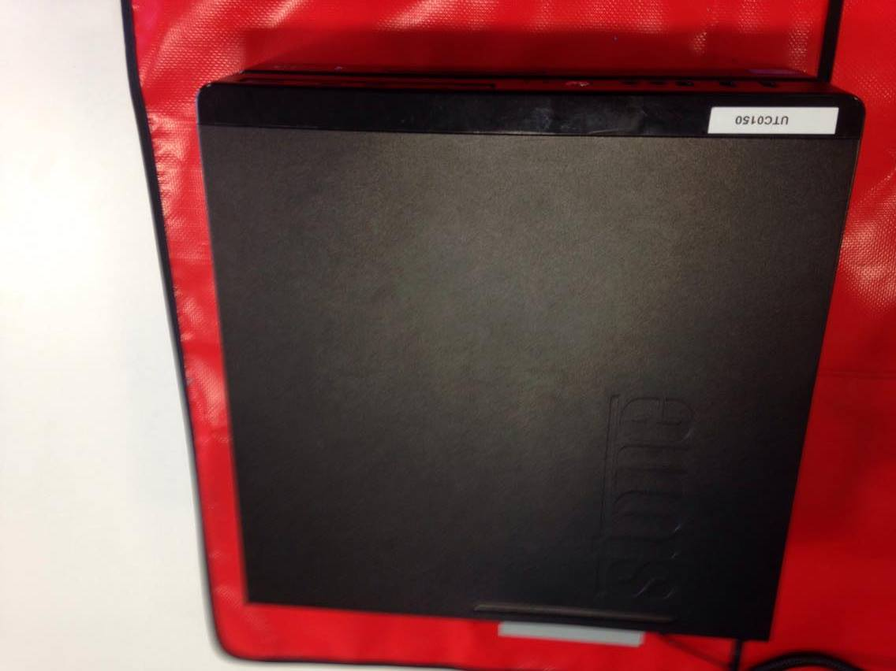

Finally, the case is put on the PC. The case protects the components and helps direct air flow for cooling.

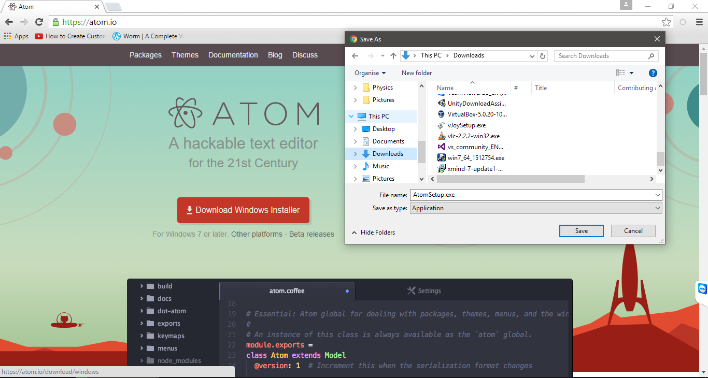

This screenshot shows the installer for Atom, a feature-rich text editor, being downloaded.

This is Atom’s installer window. Because Atom is such a simple program, it does not have any setup options, it simply does everything automatically.

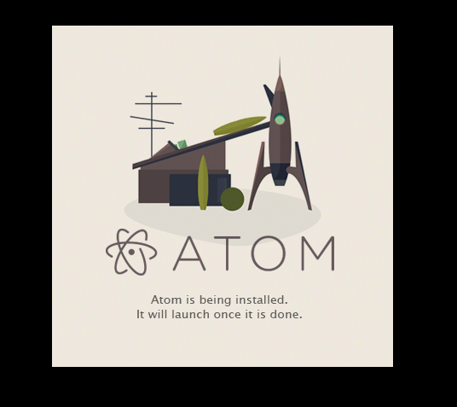

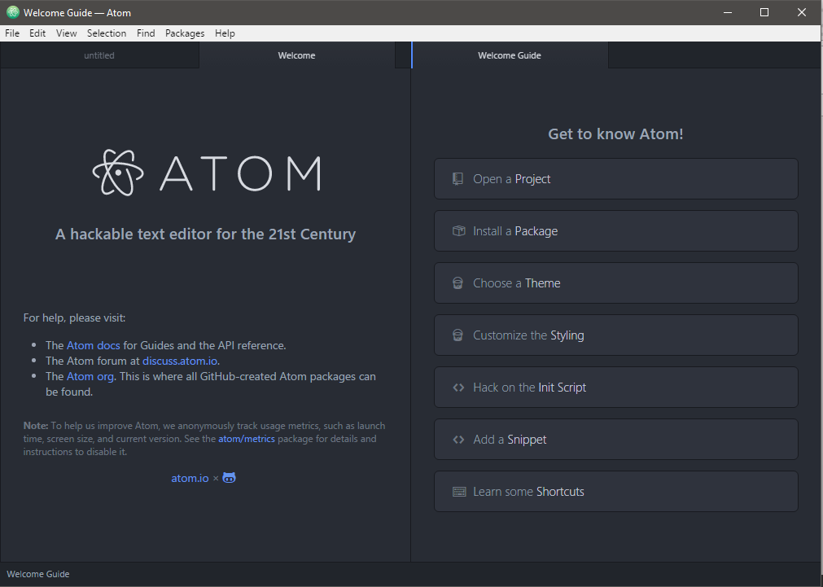

Once installed, Atom launches automatically and is ready to use.